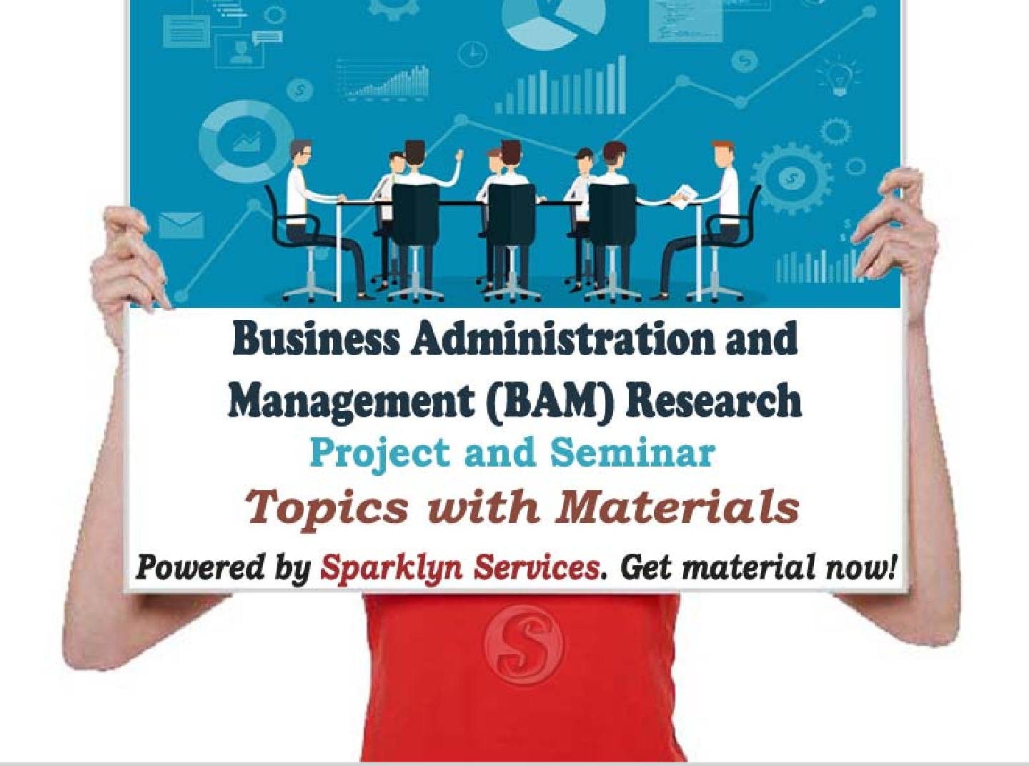

Business Administration and Management (BAM) Project / Seminar Topics and Materials

@SparklynServices

# [Project Topics under Business Administration and Management](http://127.0.0.1/Sparklyn/Document%20of%20Projects.php?searchspark=Business%20Administration%20and%20Management%20(BAM)&project_topics_under_business_administration_and_management)

Business Administration and Management Project and Seminar Topics library is setup for Undergraduate & Postgraduate Students in Nigeria and other Countries, who desire for guidelines in pdf or microsoft word on how to achieve their final year project or seminar research goal in Business Administration and Management (BAM).

**How it functions;**

* Select at least three(3) topics from Our library;
* Write a proposal for your preferred research topics;
* Present the topics to your supervisor for approval;
* Contact Us with +2348030511988 after approval to get the complete research material (Chapter 1-5 and References).

# [Seminar Topics under Business Administration and Management](http://127.0.0.1/Sparklyn/Document%20of%20Projects.php?searchspark=Business%20Administration%20and%20Management%20(BAM)&seminar_topics_under_business_administration_and_management)

Business Administration and Management Seminar Topics research write-up can be achieved by getting a seminar research writing format and extracting the chapters or sections needed from acquired project material (Chapter 1-5 and References). Also, ensure to make use of future tense in place of past tense during write-up. For example;

Past Tense: The research work was done with…

Future Tense: The research work will be done with…

# [Project / Seminar Topics on Business Administration and Management with](http://127.0.0.1/Sparklyn/Document%20of%20Projects.php?searchspark=Business%20Administration%20and%20Management%20(BAM)&project_seminar_topics_on_business_administration_and_management-with-materials) [Materials](http://127.0.0.1/Sparklyn/Document%20of%20Projects.php?searchspark=Business%20Administration%20and%20Management%20(BAM)&project_seminar_topics_on_business_administration_and_management-with-materials)

Below is the list of available proposal topics on Business Administration and Management (BAM) that can be selected for proposal write-up submission.

# [List of Available Topics on Business Administration and Management](http://127.0.0.1/Sparklyn/Document%20of%20Projects.php?searchspark=Business%20Administration%20and%20Management%20(BAM)&list_of_available_topics_on_business_administration_and_management)

* The Impact of Staff Training on Employee Performance (A Case Study of Federal Polytechnic Nekede, Owerri)
* Organizational Reward System and Its Impact on the Productivity of Staff (A Case Study of Imo State Environmental Protection Agency (ISEPA))
* Capital Market Reforms and Equity Financing of Business Firms Issues, Problems and Prospects
* The Effect of Work Ethics on Organizational Performance in Public Sector Organization (A Study

of PHCN, Owerri)

* Strategic Planning and Control:Tool for the Growth and Survival of Small and Medium Scale Enterprises (A Case Study of Star Paper Mill, Aba, Abia State)
* Impact of Employee Welfare in Enhancing Organization Efficiency (A Case Study of Imo State Public Service)
* Impact of Social Responsibility on Businesses (A Case Study of Unilever Plc Lagos)
* The Impact of Foreign Capital on Entrepreneurship Development in Nigeria
* Causes and Consequences of Business Failures in Nigeria (A Case Study of Selected Businesses in Owerri, Imo State)
* The Impact of Human Relationship on the Achievement of Organisational Goals (A Case Study of Unilever Nigeria Plc Aba, Abia State)
* The Influence of Business Environment on the Productivity of Business Organization (A Case Study of Selected Organization in Owerri)
* The Role of Management Information System in Effective Productivity (A Case Study of Selected Business/Firms in Owerri)
* The Impact of Delegation of Authority on Organizational Efficiency (A Case Study of Pz Industries Plc Aba)
* Impact of Economic Policy on SMES Performance
* Strategies for Promoting Productivity in Civil Service (A Case Study of Enugu State Civil Service Commission)
* The Impact of Socio-Cultural Environment on Organisational Growth in the Private Sector (A Case Study of Selected Organization in Nigeria)
* The Impact of Conflict Management on Productivity in the Nigeria Banking System (A Case Study of Union Bank Plc Anambra State)
* The Impact of Wages and Salaries Administration on the Efficiency of Government Owned Establishment in Nigeria (A Study of Power Holding Company Owerri)
* Effects of Strategic Planning as a Tool for the Growth and Survival of Small and Medium Scale Enterprises (A Case Study of Star Paper Mill, Aba, Abia State)
* The Impact of Organizational Bonus Scheme on Employees' Productivity (A Case Study of Selected Banks in Owerri)

[**Click here to view more proposal topics**](https://sparklyn.com.ng/business-administration-and-management-bam-project-and-seminar-material)

**For other departmental proposal topics -** [**Click here**](https://sparklyn.com.ng/project-and-seminar-materials)